Wayward Whiskers Foundation
In Partnership with the San Antonio Feral Cat Coalition
Application for Food Assistance
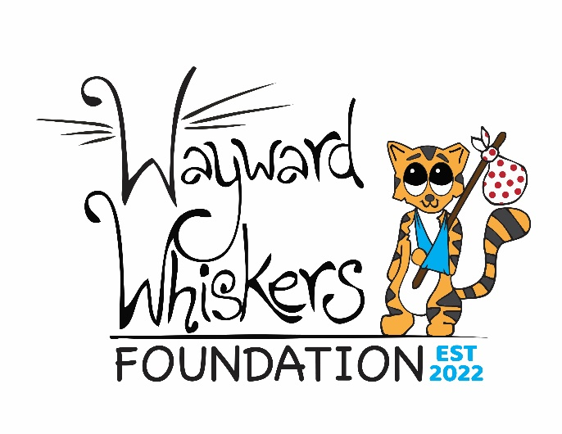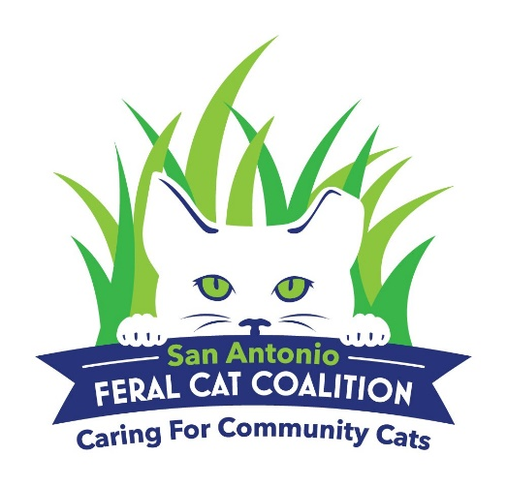
Please read before completing:
The food assistance program is open to colony caretakers who are members of the San Antonio Feral Cat Coalition, practice Trap-Neuter-Return, and manage a colony registered with the City of San Antonio Animal Care Services. We will ship food directly to you on a monthly basis via Amazon or Chewy. We will also have food pickup options available once a quarter.
If you are not a member of the San Antonio Feral Cat Coalition, please call 210-877-9067 or email info@sanantonioferalcats.org for more information.

Email To: waywardwhiskersfoundation@hotmail.com
www.wayward-whiskers-cat-rescue.org
www.sanantonioferalcats.org

Wayward Whiskers Foundation
In Partnership with the San Antonio Feral Cat Coalition
Application for Food Assistance
Name of Colony Caretaker: ______________________________________________________________
Address: __________________________________________________________________________________
City/State/Zip: __________________________________________________________________________
Phone number: ______________________________________
Email Address: ________________________________________________________________________________________
Number of cats you are feeding: _________________
Address or general description of colony location(s): ___________________________________________
__________________________________________________________________________________________________________________________________________________________________________________________________________________
Zip code of colony location(s): ______________________________________________________________________
Are all cats in the colony(ies) spayed or neutered? ☐Yes ☐No
If not all cats are fixed, how many still need to be spayed or neutered? ________________________
Do all cats appear to be healthy? ☐Yes ☐No
If no, what are their symptoms? ____________________________________________________________________
_________________________________________________________________________________________________________
Are there any friendly, adoptable cats in your colony? ☐Yes ☐No
If yes, how many? _________________________

- ☐ I acknowledge that I have read How to Properly Feed Feral Cats (attached) and will abide by the feeding guidelines provided.
- ☐ I understand that if there are multiple feeders in the same colonies only one feeder will receive assistance from the food program. This is to avoid overfeeding and food waste.
- ☐ I understand that if there are any cats that have not been spayed or neutered or if any new cats arrive at the colony, I will notify the San Antonio Feral Cat Coalition so they can assist with trapping and fixing the cats as they have capacity.

I certify that all information I have provided is true and accurate.
Signed: _________________________________________________________________
Print Name: ____________________________________________________________
Date: ____________________________________________________________________
Please email this application to waywardwhiskersfoundation@hotmail.com.

For staff use only:

Approved by:
Application Approved:

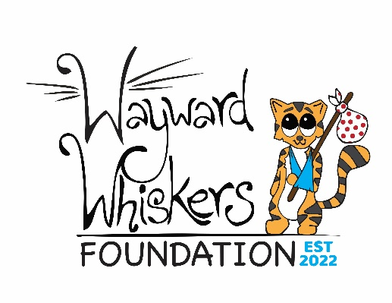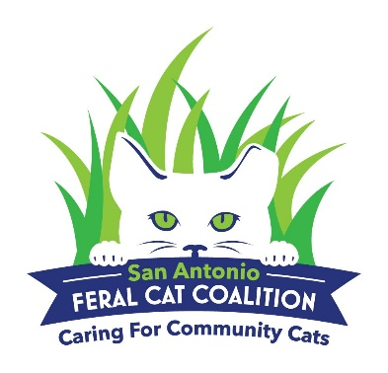

How to Properly Feed Feral Cats
First and foremost, the cats MUST be fixed! If the cats are not spayed or neutered the colony will continue to increase in numbers and will eventually become unmanageable.
- Do not overfeed. Cats will only eat until they are full and will walk away from a bowl that still has food in it. This will attract ants, birds and flies and food will be wasted.
- Don’t litter. Do not use paper, plastic, foam or any other kind of bowls or containers that will blow away to feed in unless you plan to pick them all up after feeding. Use tortillas as plates or wait until the cats are finished eating to clean up the bowls.
- Feed at the same times every day. This will help you keep track of which cats may need medical attention or any new cats that show up at the colony.
- Be inconspicuous. We all know that not everyone is a fan of feral cats, and the last thing you want to do is draw negative attention to your feeding. This could put you and the cats in danger.
- Be polite to the local business owners and/or residents.
- Educate. If you are feeding at a business, let the owner know what you are doing and why having feral cats around is a good thing. They are great pest control! Make sure they understand that you are getting them fixed to prevent population explosions.
- Contact the San Antonio Feral Cat Coalition if there are any cats that need medical attention or need to be spayed/neutered.

